>
slabye i silnye razryvy reweniyanelineinyh uravnenii
каныбек тогжан mkm

> restart;
> with(plots);
Warning, the name changecoords has been redefined

vvod ishodnyh dannyh;

> f :=u->cos(u); u0 :=x->sin(x);
решение уравнение u-U0(u-f{x}t)=0 pri t=0;

> implicitplot (u-u0(sin(x))=0, x=-1..1, u=-1..1);
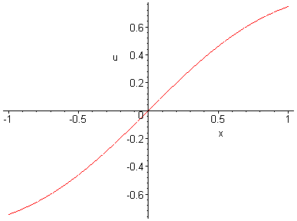

> implicitplot(u-u0(x-diff(f(u),u)*0.2)=0, x=-1..1, u=-1..1);
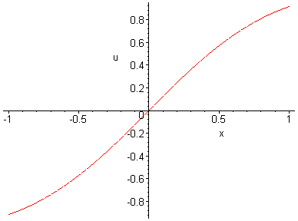
> implicitplot(u-u0(x-diff(f(u),u)*0.2) , x=-1..1, u=-1..1);

> C:=implicitplot((u-u0(x)=0, x=-1..1, u=-1..1), style=line, color=blue):
> A1:=implicitplot((u-u0(x-diff(f(u),u)*0.1)=0, x=-1..1, u=-1..1), style=line, color=red):
> A2:=implicitplot((u-u0(x-diff(f(u),u)*0.2)=0, x=-1..1, u=-1..1), style=line, color=black):
> A3:=implicitplot((u-u0(x-diff(f(u),u)*0.3)=0, x=-1..1, u=-1..1), style=line, color=brown):
> A4:=implicitplot((u-u0(x-diff(f(u),u)*0.4)=0, x=-1..1, u=-1..1), style=line, color=yellow):
> A5:=implicitplot((u-u0(x-diff(f(u),u)*0.5)=0, x=-1..1, u=-1..1), style=line, color=grey):
> A6:=implicitplot((u-u0(x-diff(f(u),u)*0.6)=0, x=-1..1, u=-1..1), style=line, color=green):
> A7:=implicitplot((u-u0(x-diff(f(u),u)*0.7)=0, x=-1..1, u=-1..1), style=line, color=violet):
> A8:=implicitplot((u-u0(x-diff(f(u),u)*0.8)=0, x=-1..1, u=-1..1), style=line, color=pink):
> A9:=implicitplot((u-u0(x-diff(f(u),u)*0.9)=0, x=-1..1, u=-1..1), style=line, color=orange):
> display({C,A1,A2,A3,A4,A5,A6,A7,A8,A9},axes=boxed,scaling=constrained,title=`Cosine and Tangent`);

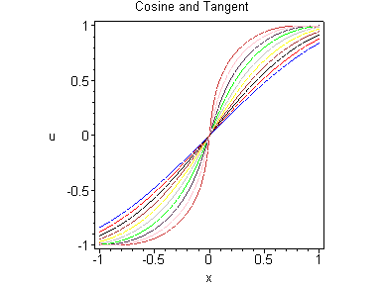
>
> ?animate
> animate((u-u0(x-diff(f(u),u)*0.9,x=-1..1,u=-1..1,t=0..1,frames=50);
Error, `;` unexpected

>

